**Trend Nest Store Power BI Capstone**

1. **Top Categories by Total Price:**
   * Identify and visually represent the top 10 product categories by total sales.

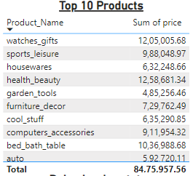

**2.Delayed Orders Analysis:**

Determine the number of delayed orders in each category. An order is considered delayed if the actual delivery date is later than the estimated delivery date.

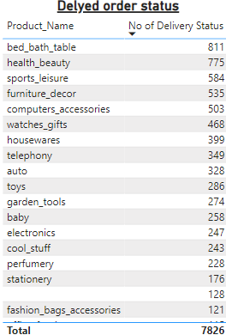

1. **Monthly Comparison of Delayed and On-Time Orders:**

Create a dynamic visual that compares the number of delayed orders to the number of orders received earlier for each month. Utilize the drill through cross-report feature to provide a detailed analysis of late and on-time deliveries.

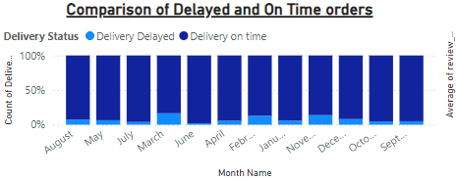

1. **Payment Method Analysis:** Analyse the most frequently used payment methods by customers using a visually appealing representation, such as a pie chart or other suitable visuals.

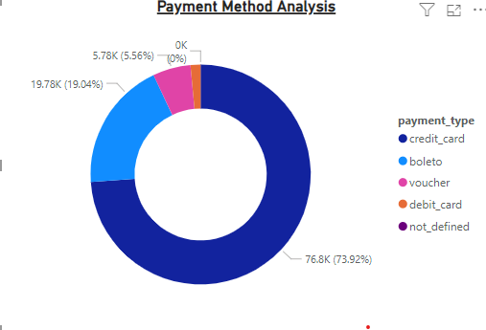

**5. Product Rating Analysis:** Determine the top 10 highest-rated products and the bottom 10 lowest-rated products using a bar or column chart.

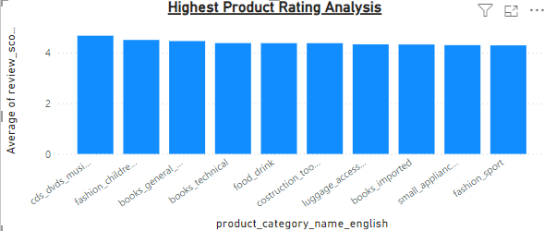

**6.State-wise Sales Analysis:** Identify and visually represent states with high and low sales, providing a clear understanding of regional sales performance

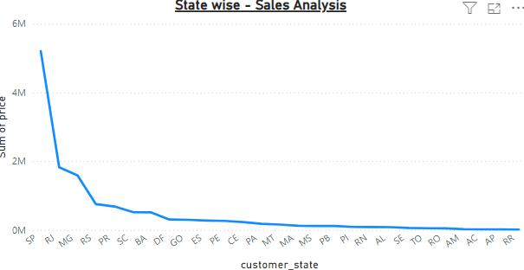

**7.Seasonal Sales Patterns:** Investigate and visualize any seasonal patterns (Quarterly) or trends in sales data over the course of the year.

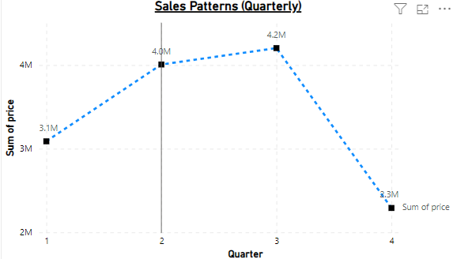

**8. Revenue Analysis:** Determine the total revenue generated by TrendNest Store and analyse how it changes over time (Yearly). Represent this information through suitable visuals to highlight trends and patterns.

